Normalization Exercise

1) Your task in this exercise is to move the un-normalized table to 3NF. To do this, use the dependency diagram.
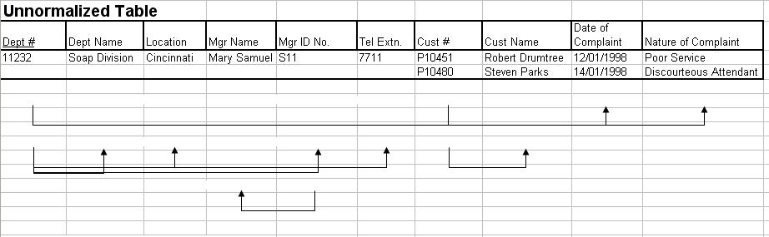

2. Employee and Projects
The table below depicts the requirements for a business consultancy working on local and international projects.
Emp-No | Emp-Name | Dept | Dept Manager | Proj-id | Proj-Start-Date | Location | Weeks-on-Project
005 | Smith | Marketing | Jones | (A, B, C) | (12-93,  06-94,  09-94) | (Poole, Plymouth, Portsmouth) | (11, 15, 6)
007 | Bond | Accounts | Bloggs | (B, D) | (06-94,  06-94) | (Plymouth, Berlin) | (3, 9)
009 | King | Info Systems | Hurne | C | 09-94 | Portsmouth | 10
010 | Holt | Accounts | Bloggs | A  B  D | (12-93, 06-94,  06-94) | (Poole,  Belfast, Hamburg ) | (21,10, 12)
Emp.no is the primary key. Employees work on a number of projects concurrently. Weeks-on-project represents the number of weeks that an employee has spent on a particular. The employee number, emp-no, and the project identifier, project-id, are unique identifiers. The department manager, manager, is the name of the current manager, i.e., there can be only one manager per department. A project can take place in several locations (i.e Employees can work on a project from their location). You are required to show the first, second and third normal forms.

